Mapping groundwater hardness in wells as a source of drinking water for the people of Bangkalan Regency

ABSTRACT
Herce Farida Solossa 20.2018.2.00117 Mapping of Groundwater Hardness Distribution of Drinking Water for Bangkalan District Community, in 2019. Thesis, Department of Environmental Engineering, Faculty of Civil Engineering and Planning, Adhi Tama Institute of Technology Surabaya, Advisor Dr. Yulfiah, ST., Msi.
Water hardness is the content of certain minerals in water, generally calcium (Ca) and magnesium (Mg) ions in the form of carbonate salts and this content if it exceeds quality standards can have an impact on human health. The purpose of this study is to map the distribution of groundwater hardness as a source of water supply in Kab. Bangkalan. The sample of this study is shallow wells with a depth not exceeding 20 m.
This type of research is a descriptive study with a qualitative and quantitative approach. The research sample was taken as many as 18 following the number of sub-districts in Kab. Base Samples taken are water source wells used by the community. Sampling time is the dry season. Samples taken are stored in bottles and immediately taken to the laboratory for examination. Sampling locations are made in the form of maps with the ArcGis application.
The conclusion of this research is that the level of hardness in groundwater in Kab. Base has moderate value - maximum. The distribution of hard water is also evenly distributed throughout the Kab. Base with the maximum distribution from east-west to east and east-east while the hardening is starting from north and northeast to south, southwest and west. This suggestion that can be made is that residents who use shallow wells should use a filter and cook it first for drinking needs. Keywords: Mapping, hard groundwater, drinking water sources.
PIG
INTRODUCTION

Background

Groundwater as a non natural resource
biological which is part of the environment so that there is an interaction between groundwater resources with the environment as a whole.
The quality and quantity of groundwater is greatly influenced by many factors and one of the factors in water quality is a chemical factor in which there is a hard element which means is the womb minerals certain in water, generally ion calcium (Ca) and magnesium (Mg) in the form salt carbonate. Groundwater hardness can affect human health andby Rizka Bobihu (2012)Urinary tract stone disease is one of the health problems, among the causes is the hardness of water consumed. Thus, groundwater availability and water quality greatly affect the health of humans who consume hard water. Based on PERMENKES no.416 in 1990 said that the Standard Value of hardness allowed in water is 500 mg / l. Groundwater quality can also be influenced by where it is located.
The Regional Disaster Management Agency (BPBD) of Bangkalan Regency, East Java, noted that from 18 districts in Kab. Base 79 villages have the potential to experience drought and clean water crisis or in other words the lack of clean water in the 2017 dry season and PDAMs in Bangkalan Regency are very uneven and only directed to Kab. Bangkalan sub-district which is the capital of the regency and 17 other sub-districts are not well controlled by the PDAM. BPPSPAM said that three PDAMs in Madura were unhealthy namely PDAM Sampang, Bangkalan and Pamekasan.
By following developments very quickly, it can make Bangkalan Regency there will be a lot of residents and offices and industry that will add PDAM water users so that people around Bangkalan sub-district will receive less supply from the PDAM because it is only used by residents of Bangkalan District. Therefore, research on drinking water in the Karts area is important. Because this groundwater hardness study in shallow wells associated with free aquifers that are not deep so that the effect is very large in the rainy season, it is more effective to take and test samples is the rainy season (June - July 2019).
  - Formulation of the problem
- What is the level of groundwater hardness in Kab. Base?
- How is the mapping of groundwater hardness in Kabak District?
- How is hard water available with the Effect of Geology Process?

Aim
- Analyzing the level of groundwater hardness in shallow wells in Kab. Bangkalan,

Mapping the spread of groundwater hardness in wells as a source of drinking water for the people of Bangkalan Regency
- Conduct analysis related to groundwater containment containing hard water with geological processes in the Bangkalan Regency

Scope of problem
1 Mapping groundwater hardness distribution in shallow wells in Bangkalan Regency.
2 Groundwater analysis is focused on the level of groundwater hardness as a source of water drinking by the people in the district. Base.
3 Analysis of whether there is a relationship between hardness of hard water and the Geological Process in Base.

Scope
1 The water examined is water in shallow wells.
2 Water hardness in this study is temporary hardness.
3 Sampling time for analysis is the dry season time.

CHAPTER III

RESEARCH METHODS

Types of research
This research is a study of quantity and quality.
  - Location
The location of this research is located at Bangkalan Regency. Which consists of 18 districts.

Sumber data
      - Primary data :
        - 18 Groundwater Sample from Groundwater Sample Well
        - Geological Structure Data (regional), Karts area, Aquifer Lithology, Aquifer Productivity (Web Resources ESDM One Map Indonesia Overvierview (https://geoportal.esdm.go.id/monaresia/home/)
- Secondary Data: Administrative Map of Kabak. Scale 1: 200,000, Geological Map of Surabaya - Sapulu Sheet, Java scale of 1: 180,000, Theory / Literature Review , Administrative settlement, including processing permits.

Tools and Materials
Table 3.2 Tools and materials that will be used for research.
No. | Tool | Use
1 | Water | Sample
2 | Global Positioning System (GPS) | Determine location coordinates
3 | Camera | Documentation
4 | Computers and software (software) | Report writing and map making.
5 | Lab Equipment | Testing Hardness and Water Quality

Research Flow

¹Preparation Phase: literature study about the area of ​​research study (guidance for determining the title and location of research). 2 Proposal Qualification Stage: initial survey and title determination as well as location determination as well as seminar on the Thesis title seminar. 3 Stage of Proposal Preparation: Follow-up Survey and then do the preparation of the Thesis Proposal body which includes Introduction, Literature Review and Research Methods as well

holding a Proposal hearing. 3 Stage of Thesis Development: Thesis Development (Chapter I Introduction - Chapter V Closing).

CHAPTER IV

RESULTS AND DISCUSSION

4.1. The relationship between groundwater hardness and the Geological Process of Basis District

4.1.1. MorphologyKab. Base

Morphological appearance in the field shows the morphology of the hills to form anticline / syncline (folding). This fold is the place where there is hard groundwater with maximum content. This is also confirmed by the 2019 ESDM data from Indonesia which states that the geological structure in the study area is a fault. and anticline / folds. The shape of the hill morphology (anticline / fold) is in the middle of the Bangkan Regency around the districts of Konang, Kokop, Klampis, Sepulu and Geger, which can be seen in the attached map of the geological structure. The direction of the shape of the hills morphology is Northwest - East.

4.1.2. District Stratigraphy. Base
Table.4.1 Stratigraphy of Kab. Base
The Tawun Formation is older than the Early Miocene age, then followed by the Watukoceng formation above the Plistocene age, then followed by the Madura formation younger than the previous formation and the age is Miocene to the Pliocene, and followed by a younger formation again namely Pamengkasan formation with Middle Miocene age and the last is Alluvium formation (overburden) with early Miocene age. This stratigraphy uses superposition law where the formations located below are the oldest (International Subcommission on Stratigraphy and Terminology, 1961).
4.1.3. Structural Geology
The location of Kangkalan Regency is in the process of geological structure that affects groundwater generation. Grological structure can also determine the lithology and soil above it, not only that but also determine what vegetation is on it. The geological structure that occurs in the Bangkalan district area based on the Indonesian ESDM data is twofold, namely the fold (Anticline) and the Fault (fault), Appendix 5 of the Geological Map of the Research Area Structure.
- Multiples (anticline)
The fold extends from the northwest (Klampis District) through the middle (Geger District) then eastward (Konang District). The lithology that characterizes the fold is solid lithology.
The results of measurements in the field show that there are two anticlines. First, anticline wing (east) N 233 E / 74 and anticline wing (west) N 145 E / 56, with anticline axis south N 195E / 60 E. Second anticline, anticline wing (east) N 150 E / 61 and wing anticline (west) N 110 E / 43, with anticline axis south of N 130 E / 50.
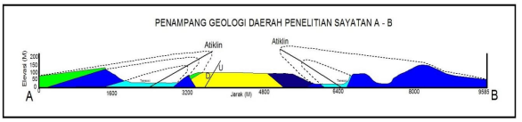
Figure 4.6. Cross section reconstruction shows the folds that form anticlines.
The results of geological data analysis show the structure of folds and faults, anticline thickness, type and age of lithology, as well as regional morphological forms. It can also be seen that the direction of forces acting on the study area is generally from the South - North.
The results of the lithology position reconstruction and muscular structure that occur can be seen that the folds that form the anticline are the classifications of Sub Surface data obtained by seismic or drilling. While surface data can be obtained by geological mapping. Based on the geological mapping carried out in the study area, it can be concluded that the Mud Volcano in the study area is formed by anticline, fault and direction acting on the burly.
The anticline in the research area was formed towards the West - East. The shape of the morphology in the study area also shows the bumpy hills that are covered by soild (alluvial) very thick. The morphological shape around (outside) the study area also shows the rolling hills (fig. 4.7) and regionally shows that the spread of anticline extends from the East - West direction.
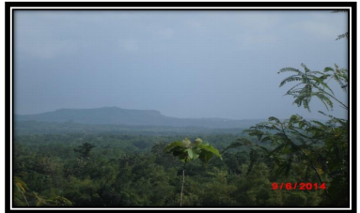
Photo of the Form of Anticline Form in the East-Southeast - Northwest (N-S),
Direction of Camera to the South.
Regionally, the geological structure of the island of Madura belongs to a bloom zone characterized by the anticlinorium to the east. Anticlinorium Rembang is bordered by folds and kendeng faults in the south. The fold path of the Kendeng zone is almost parallel to the Rembang zone, which is directed west - east with a slope towards the south. Observation of the MSS Landsat image from the EARTHSAT results shows the anticlinorium axis on the island of Madura leads southwest - northeast.
- Fault (Fault)
Based on the results of research in 2014 The field of faults in the Geger sub-district was shown by the existence of different types of lithology. In field I, the types of lithologists are limestone and marl. Whereas in the second field are stone and sandstone. Based on micropaleontological analysis, it was shown that lithology in the field I was in Early Miocene age and in Field II in middle miocene age.
Other evidence of the results of the structure process in addition to the water density in the study area is that there is also a mud volcano in the commotion district of Banyoning Laok village with the direction of the structure and structure, namely faults and folds.
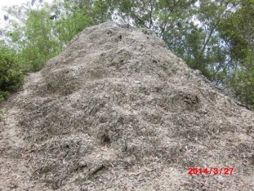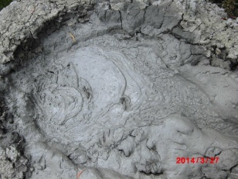
Figure 4.2 Appearance of Mud Volcano (Mud Volcano), Due to activities of geological structures (Sesa and Folds) in Geger District
Based on field observations and reconstruction results above, faults that affect groundwater hardness in the study area are down / normal / flat faults in the southeast-northwest direction, while fold (anticline) with east to west direction.
    - Karst Region
Bangkalan Regency is included in Karts Region with level 2, which means karst area with KBAK delineation results of the investigation. The karst area extends from North to West then then south. The sub-district located in the area of ​​Karts is Socah,Kamal, Labeng, Kwanyar, Blega, Galis, Tanjung Bumi, Sepulu, Klampis, Aros Baya, Bangkalan, Burneh and Tanah Merah. Whereas there are no karts or few, namely Modung, Kokop, Konang, Geger and Tragah. The structure that occurs in the area of ​​the karts is folds and bedding and is composed of integrated limestone lithology. (appendix map of the Karst Area for the Research Area).
    - Aquifer Productivity
Aquifer productivity or in other words a good aquifer in Bangkalan Regency, namely:
- Aquifers with flow through inter-grain space (medium productive aquifers with wide spread) and channels (local, productive aquifers). This aquifer is light blue: Socah, Bangkalan, Arosbaya, Burneh, tragah, Blega, Modung, Konang, Sepulu, Kwanyar
- Aquifers with flow through fracture chambers and channels (local, productive aquifers), these aquifers are light green: Kamal, labeng, red soil, galis, Konang, Sepulu, Kwanyar
- Small productive aquifers with rare groundwater (small / local productive aquifers). This aquifer is brown: Konang, Kokop, Sepulu, Kwanyar
- Aquifers with flow through fracture chambers and channels (medium productive aquifers), these aquifers are pale green. (Appendix Aquatic Productivity Map of Research Areas): Konang, Kokop
    - Aquifer lithology
Aquifer lithology which is spread in Kab. Base namely Batuan Padu and Limestone. Padu Stone is a compact stone which is Limestone. Based on the stratigraphy of Kab. Base (Table 4.1) limestone is always present in every formation, this shows that limestone spreads throughout the Kab. Base and according to its classification, limestone in the study area is reef limestone. The process of forming reef limestone originates from the collection of plankton, mollusks, algae, which then forms reefs so that reef limestone comes from organisms. Sedimentary rocks which have the main mineral composition of calcite (CaCo3) are formed due to coral or reef activity in warm and shallow waters and are formed as a result of organic sedimentation.
    - Level of hardness and distribution of groundwater hardness and distribution.
  - Hardness District Base
Based on the results of lab tests from 18 samples in 18 districts in the regency base is maximum - moderate (Table 4.1), so it is concluded not meeting standards based onPerMenKes Number: 416 / Men.Kes / Per / Ix / 1990. Hardness level is based on test results that refer to CandyPerMenKes Number: 416 / Men.Kes / Per / Ix / 1990 i.e. Maximum by value > 600 and Medium with grades > 500. can be seen at Map of Spread of Groundwater Hardness Research Location.

Table 4.1. Groundwater Hardness Test (CaCo3) Results of Kab. Base.
NO | District | Method | Unit | Laboratory Examination Results | Level
1 | Aros Baya | SNI 06.6989.12.2001 | Mg / l | 630 | Maximum
2 | Bangkalan |  |  | 570 | Is
3 | Blega |  |  | 605 | Maximum
4 | Burneh |  |  | 545 | Is
5 | Galis |  |  | 510 | Is
6 | Great commotion |  |  | 610 | Maximum
7 | Kamal |  |  | 530 | Is
8 | Klampis |  |  | 550 | Is
9 | Kokop |  |  | 510 | Is
10 | Konang |  |  | 620 | Maximum
11 | Kwanyar |  |  | 615 | Maximum
12 | Labang |  |  | 570 | Is
13 | Modung |  |  | 520 | Is
14 | Sepulu |  |  | 510 | Is
15 | Laterite |  |  | 540 | Is
16 | Tanjung Bumi |  |  | 510 | Is
17 | Tragic |  |  | 515 | Is
18 | Socah |  |  | 530 | Is

Consideration: Parameters tested in the hardness test results do not meet the chemical clean requirements limits. (PerMenKes Number: 416 / Men.Kes / Per / Ix / 1990 Regarding Requirements And Supervision Of Water Quality).

  - Distribution of Hardness District of Kab. The base of the maximum level of hardness with a value of> 600 includes the districts of Aros Baya, Konang, Kwanyar, Geger, Blega. While medium level hardness with a value> 500 includes Bangkalan, Labeng, Klampis, Burneh, Tanah Merah, Kamal, Modung, Tragah, Sepulu, Kokop, Galis, Tanjung Bumi and Socah districts (Map of Groundwater Hardness Distribution of Kab. Base)

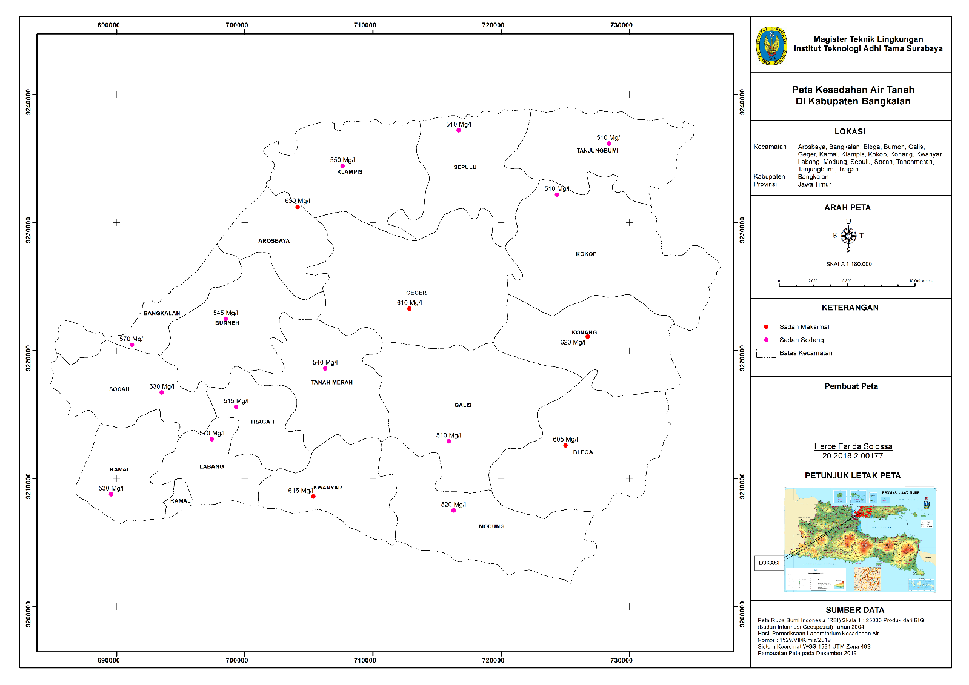

CHAPTER V
CLOSING
  - Conclusion
- The level of hardness in groundwater in Kab. Base has a moderate - maximum value.
- The distribution of hard water is also evenly distributed throughout the Kab. Base with the maximum distribution from east-west to east and east-east while the medium is ranging from North and Northeast to South, Southwest and West.
- The distribution of groundwater hardness is influenced by the structure of Geology: The fault is down / normal / flat with the direction east-southeast - northwest whereas fold (anticline) with east to west direction
  - Suggestion
- Residents who use shallow wells should use a filter and cook it first for drinking needs. while in determining the point of the well must
- Determination of the wellbore point must move away from the geological structure so as to minimize the level of hardness in the groundwater used.

BIBLIOGRAPHY
Azwar, Azrul. 1996. Maintaining Service Quality
Health (Jakarta: library
Ray of hope).
Adji, TN, Nurjani, EM, Wicaksono, D., 2014,
Zoning Potential Groundwater With
Using Multiple Parameters
Field and GIS Approach in the Regions
Coastal, UGM Vocational School Grant,
2014. Zoning Potential Groundwater With
Using Multiple Parameters
Field and Sig Approaches in Regions.
Ahmadsholihan, Definition and Characteristics of Cat and Non-Cat Regions, All About Exploration, January 1 2014.
Bangkalan Regional Disaster Management Agency (BPBD)
Technology Assessment and Application Board (BPPT) in 2002
The Agency for the Improvement of Drinking Water Supply Systems (BPPSPAM)
Bear J, 1979, Hydraulics of Groundwater,
McGraw-Hill, Inc., New York.

Bambang Prastistho, Praise Pratiknyo, Achmad Rodhi C. Prasetyadi, M. Ridwan Massora, Yulian Kurnia Munandar, Ministry of Research, Technology and Higher Education University of the "Veteran" National Development University of Yogyakarta Research Institute and Community Services 2018.
Bambang Triatmodjo, 2008, "Applied Hydrology", Beta Offset, Yogyakarta.
Chow, et.al., 1988. Applied Hydrology. United States: McGraw-Hill.
Danaryanto, et al, 2008, Groundwater Management Based on Groundwater Basin.
Ministry of Energy and Mineral Resources, Jakarta.
Directorate of Environmental Geology, Dep. Mining and Energy (1982).
Eko Haryono. 2001. Hydrological Value of Bukit Karst. National Eco-Hydraulic Seminar. Civil Engineering, Gadjah Mada University, Yogyakarta 28-29 March 2001.
ESDM One Map Indonesia Overview 2019
Fetter, CW 1994. Applied Hydrogeology.
Prentice-Hall, Inc., New Jersey.
Gomes. 2001. Resource management
human. Yogyakarta: Andi offse
Hadi, Sutrisno. 2000. Research Methodology, Yogyakarta: Andi Yogyakarta.
Unpad Soil and Land Resources Student Association. 2012. Conservation of Land and Water [Http://Himatan.Ilmutanah.Unpad.Ac.Id/Conservation- Land and Water /] Accessed May 20, 2018.Suharto Sb. 2013. Soil and Water Conservation Training Module. Yogyakarta (Id): Serayu Opak Progo Watershed Management Office, Yogyakarta.
Hamed Soleimani, Omid Nasri, Boshra Ojaghi ,, Hasan Pasalari, Mona Hosseini, Bayram Hashemzadeh, Ali Kavosi, Safdar Masoumi, Majid Radfard, Amir, Adibzadeh, Ghasem Kiani Feizabadi. Data in Brief 20 (2018) 375-386. Drinking water quality data uses water quality index (WQI) and assessment of ground water quality for irrigation purposes in Indonesia Qorveh & Dehgolan, Kurdistan, Iran.
Kodoatie, Robert J. "Introduction to hydrogeology"
(1996).
The Great Dictionary of Indonesian Wikipedia,
https://www.arcgis.com/features/index.html
Linsley, RK and Franzini, JB, 1989, Engineering
Water Resources, Volume 1, Third edition,
Translation of Djoko Sasongko, Erlangga, jkt.
M.Ali Akbar Aribiyanto, 2016, Mapping of the Level of Water Well in West Surabaya Region Based on the Application of Geographic Information Systems (GIS).
Mi Lin, Asim Biswas, Elena M.Bennett ... Journal of Environmental Management. Volume 235, April 1, 2019, Pages 84-95. The spatio-temporal dynamics of groundwater storage changes in the Yellow River Basin.
M.Anim-Gyampo, GKAnornu, EKAppiah-Adjei, SKAgodzo Groundwater for Sustainable Development. Volume 9, October 2019, 100217. Quality and health risk assessment of shallow groundwater aquifers in the Atankwidi basin of Ghana. (hsl 1)
Republic of Indonesia Government Regulation, number 43 of 2008 concerning Groundwater
Regulation of the Minister of Health Number: 416 / Men.Kes / Per / Ix / 1990 Regarding Water Quality Requirements and Monitoring.
Minister of Health Regulation RI Number 32 Year 2017 Regarding Environmental Health Standard Quality Standards and Water Health Requirements for Sanitation Hygiene, Swimming Pools, Solus Per Aqua, and Public Baths
Opportunities for Using Groundwater for Sustainability of Capturing Water Resources The Benefit Of Groundwater For Water Resources Sustainability Popi Rejekiningrum Agro-climate and Hydrological Research Institute Jl. Student Army 1a Bogor 16111.
Rizka Bobihu 811 408 090 Test for Hardness of Ca and Mg Source of Drinking Water in the Occurrence of Urinary Tract Disease in Barakati Village, Batudaa District, Gorontalo Regency, 2012.
Rp. Dhok, Patil and Ghole in 2013, Violence of Groundwater Resources and Their Conformity for Drinking Purposes. Department of Environmental Sciences, Pune University and Shardabai Pawar Mahila Mahavidyalaya, Shardanagar, Malegaon Bk. Baramati, Pune, Maharashtra, India. VSBT School of Agricultural Biotechnology, Vidyanagari, Baramati, Maharashtra, India. Coordinator, Academic Cell, National Virology Institute, Pashan, Pune, Maharashtra, India.
Shahid and Nath (2002), Rose and Krishnan (2009), Nagarajan and Singh (2009), Yeh, et al. (2009), and Preeja, et al. (2010) concerning the Identification of Groundwater Potential in Areas with Different Forms of Land Using Several Field Parameters and GIS Approach in Parangtritis, DIY by Tjahyo Nugroho Adji, Dhoni Wicaksono, Emilya Nurjani.
Saraf, AK and Choudhury, PR (1998)
Integrated Remote Sensing and GIS
for Groundwater Exploration and Identification of Artificial Refill Sites. International Journal of Remote Sensing, 19, 1825-1841. http://dx.doi.org/10.1080/014311698215018.
Sutrisno, et al. 2010. Safety Module,
Health, Work and the Environment
Life. 60 Jakarta: Yudisthira.

Soemarto, CD, Ir, BIA Dipl H, Hydrology

Engineering, PPMT, Malang, 1989.

Soetarto, ES, 2008. Microbiology Practicum Instructions for Biology Faculty Students. Gadjah Mada University, Yogyakarta.

Sosrodarsono Suyono., Takeda Kensaku, (1976),

Hydrology for Watering,

PT Pradnya Paramita, Jakarta.
Suharyadi. 1984. Diktat Lecture
Geohydrology. Yogyakarta: Department
Geology engineering, Faculty of Engineering, UGM.
Slamet, Juli Sumirat., 1994, Health
Environment, First Edition, Publisher
Gajah Mada University Press.
Suripin 2002. Conservation of Land Resources
and water. Yogyakarta: Andi Publisher.
Suriaman, E. and Juwita (2008) Water Quality Test.
Journal of Food Microbiology. UIN
Poor.
Sarwono, Sarlito Wirawan. 2005. Psychology
Environment, Publisher
PT.Gramedia Grasindo, Jakarta.
Thomas Triadi Putranto1 * Tri Winarno1 M. Satriyo Nugroho1 Yoshi Wiweka Pp1, Preparation of Groundwater Utilization and Conservation Zones in Wonosobo Groundwater Basin (Cat), Central Java Province. Proceeding, 9th National Geographic Seminar The Role of Earth Sciences Research in Community Empowerment 6 - 7 October 2016; Grha Sabha Pramana.
Todd, DK, 1980, Groundwater Hydrology, 2nd Edition, John Wiley & Sons, New York.
Toth, 1990; in Danaryanto et al. 2008) Literature Review
Invite Invitation & Year 2004 concerning Water Resources
Xiao Zhang, Wenwu Zhao, Lixin Wang, Yuanxin Liu, Yue Liu, Qiang Feng. Environmental Sciences Total Volume 648, 15 January 2019, Pages 943-954. Relationship Between Soil Moisture Content and Soil Particle Size on a Typical Plain of Loess Plain During Dry Years.
Xinxin Zhanga, Junguo Liub, Xu Zhaoa Hong, Yangcd Xiang, Zheng Denge, Xiaohui Jiangf, Yiping Lia. Journal of Clean Production. Linking physical water consumption with virtual water consumption: Methodology, applications and implications. Volume 228, August 10, 2019, Pages 1206-1217.

