JURNAL IPTEK
MEDIA KOMUNIKASI TEKNOLOGI
 | homepage URL : ejurnal.itats.ac.id/index.php/iptek
Application of Symbolism Architecture to the Design of the Fashion Carnaval Cultural Activity Center in the City of Jember
Febriany Nurshella¹, Wiwik Widyo Widjajanti², Nareswarananindya³
Department of Architecture, Faculty of Civil Engineering and Planning, Adhi Tama Institute of Technology Surabaya
ARTICLE INFORMATION |  |  | ABSTRACT
Journal of Science and Technology – Volume 25  Number 1, July 2021  Page:  1 – 8  Date of issue :  27 July 2021  DOI:  10.31284/j.iptek.2017.v21i2.91 |  |  | Jember is one of cities in East Java which has been very famous in the world. This city is dubbed as a carnaval city because it organizes an annual festival namely “Jember Fashion Carnaval (JFC)”. It is a fashion carnaval that presents the creativity of Indonesian artists. This sort of event has so famed that many foreign visitors come and see. Jember Fashion Carnaval has become a great event of entertainment and tourism that make Jember and even Indonesian people proud of. Moreover, this event exhibits cultural and art fashion show in the international level. Unfortunately, a specific place which can accommodate this kind of activity has not been available yet. As a result, JFC and art show are paraded along the roads in Jember. Thus, a Cultural Activity Centre of Fashion Carnaval in Jember is necessary to be designed by employing symbolic architecture. To collect the data, the researcher implemented field study and literature study as well as descriptive analysis method. The macro concept of this design entitled iconic under the symbolic theme will make Jember as a Carnival city. Meanwhile, the micro concept of recreational land order is actualized in centered-circulation pattern getting the philosophy of JFC logo. The micro concept of adaptive shape occurs by adapting the shape of JFC symbol as the costume of building, whereas the micro concept of thematic space derives from the philosophy of JFC fashion products which have different themes for every event. The facilities provide show area, convention hall, organizer office, restaurant and inn, training and workshop, art gallery, and souvenir shop. They are designed to facilitate all activities related to JFC. Accordingly, this design is expected to be an area which can support JFC event for youths who want to develop and continue the art works produced by Indonesian people so that this event can last long and improve other subsequent events.  Keywords: carnaval, fashion, symbolic, Jember
E-MAIL
febrianynurshellaa@gmail.com

PUBLISHER
LPPM- Adhi Tama Institute of Technology Surabaya
Address:
Jl. Arief Rachman Hakim No. 100, Surabaya 60117, Tel/Fax: 031-5997244

Jurnal IPTEK by LPPM-ITATS is licensed under a Creative Commons Attribution-ShareAlike 4.0 International License

INTRODUCTION
The existence of a carnival can always be a magnet for tourists. Celebration of self-expression can be a form of cultural identity in a place where the carnival is held as well as a forum for the community to participate in creativity. The variety of cultures in Indonesia can be a special attraction in a carnival because Indonesia has a variety of traditional dress modes that are very cultural and each has its own unique characteristics.
The city of Jember is one of the cities in East Java which has now become global. Dubbed the City of Carnival because every year Jember holds a festival entitled "Jember Fashion Carnaval (JFC)". A fashion carnival that showcases the creativity of Indonesian artists , which is now worldwide and even has many spectators who come from various countries. What makes this JFC carnival global is the fashion theme that is firmly referenced from the archipelago and combined with things that are trending.
Jember Fashion Carnaval has become a giant entertainment and tourism event, the pride of the city of Jember and Indonesia, and has become an international fashion art and culture show. With the rise of JFC celebrations, Dynan Fariz's hope with the Jember City government is to be able to establish an area that accommodates JFC events, starting from the place for its fashion culture performances, art galleries, as well as educational places about JFC for sons and daughters who want to continue to advance the work of the nation's children. So that this event never dies and can continue to develop a series of other events. So that the JFC celebration can continue to make Indonesia proud. because its existence is not only a mere social entertainment, JFC can be a tourist and educational destination for Indonesia and the city of Jember itself.

LITERATURE REVIEW
Symbolism Architecture
Symbolism is one of the discussions of semiotics in architectural science, which means the science of signs which comes from the Greek word "semeion / sign / symbol" which means any system that allows someone to view a certain identity as a sign or something meaningful[1].
Symbolic architecture can be interpreted as the use of symbols to express ideas architecturally to show the identity of an architectural work and at the same time have symbolic meanings and values ​​that can be generated through form, structure and style[2].

Approaches to the Design of Cultural Activity Centers
In architectural design, not only the beauty of the form, but also the customs and culture of the surrounding community must be considered to create a meaningful building form. The beauty of a building lies in the proportion between the head, body, and legs of the building[3].
Fashion Carnival Cultural Activities
The cultural results created by fashion in JFC are symbols depicting people living in diverse and different characters and side by side. Fashion symbols contain complementary national insights so that they do not only look at themselves but also other people[4].

METHOD
In this research, the type of research conducted is descriptive research. In this method, observations will be made on the object of study to get an accurate picture based on the existing facts[5]. As a material for consideration and comparison of objects that match the theme of symbolic architecture and the center of cultural activities for the fashion carnival in Jember City. By using this research method, it is hoped that it will facilitate its application in designing the object.
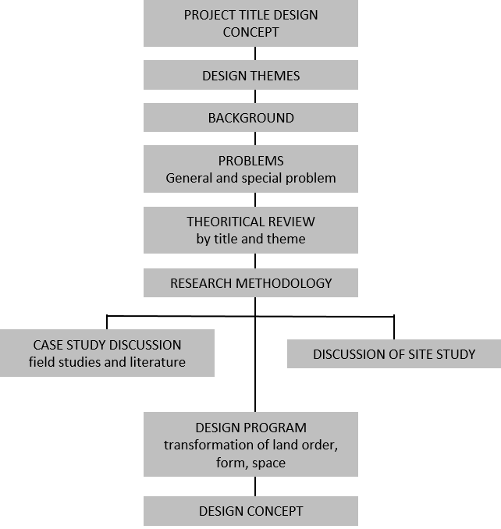

Figure 1.0 methodology diagram
Source: Personal Documentation

RESULTS AND DISCUSSION
- Comparative study
1.1 Identification and Reasons for Selection of Case Study Objects 1
Object Name : Yogyakarta Cultural Park
Land area : 1.5 ha
Building area : 1.1 ha
Location : Jl. Sriwedani No. 1 Peeling, Kec. Gondomanan, Yogyakarta City
Built Since : 1977
The reason for choosing the object of the case study in Taman Budaya Yogyakarta is because it is an area for performances and arts in Yogyakarta. The shape of the building is a relic of the Dutch era which has a strong and sturdy building structure. This building has an attractive design aesthetic value, there are large columns that make the building have a majestic impression. By selecting the object of this field case study, it is hoped that the design in the design will also have advantages in terms of aesthetics and function so that it can be useful in its use.
1.2 Identification and Reason for Selection of Case Study Object 2
Object Name : Chandra Wilwatikta Pandaan Park
Land area : 12.3 ha
Location : Sumber Gedang Kec. Pandaan Pasuruan, East Java
Built : 1963
The reason for choosing the object in Taman Candra Wilwatikta Pandaan is because it is an area for the largest performances and arts in East Java. The form of the building is a neo vernacular building which has a strong and sturdy building structure. This building has an attractive design aesthetic value. By selecting the object of this field case study, it is hoped that the design in the design will also have advantages in terms of aesthetics and function so that it can be useful in its use.
1.3 Identification and Reasons for Selection of Case Study Objects 3
Object Name : Arva School of Fashion Surabaya
Land area : 530 m2
Building area : 395 m2
Location : Ruko Golden Palace, Jl. Major General HR. Muhammad No.7 Surabaya
Built Since : 1989
The reason for choosing the object of comparative study of literature at Arva School of Fashion Surabaya is because the title of the design chosen is a place for fashion cultural activities, so all things learned in the fashion world are also related to the title of the project design that is taken. In order to be able to design buildings according to the functions required by the activities from the title taken.

1.4 Identification and Reason for Selection of Case Study Objects 4
Object Name : Taman Indonesia Rich Semarang
Land area : 12,600 m2
Building area : 420 m2
Location : Jl. Minister Supeno No. 11 A, Mugassari, Semarang, Central Java
Established : November 1, 2017
The reason for choosing the object of comparative study of literature is because Taman Indonesia Kaya Semarang is a park that has an open, unique performance area and also this park is rich in culture. Inside there are many supporting facilities that make Taman Indonesia Kaya attracts many visitors. So it is hoped that the object design can be superior in design as well as other supporting facilities. In order to become an area that attracts many visitors, not only in terms of performances but also other functions.

- Space Program
Space Organization
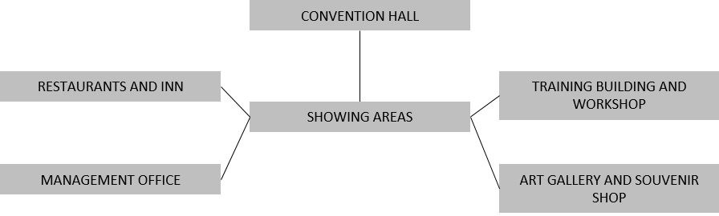

Figure 2.1 spatial organization diagram
Source: Personal Documentation

- Site Analysis
The location of the land to be used is precisely in Tegalrejo, Jember Lor, Kabupaten
Jember, East Java. with the selected land area is 3.8 Ha. The land boundaries are as follows:
following :
North : Empty land
South : Vacant land and roads
East : Settlement
West : River

Figure 3.1 site analysis
Source: Personal Documentation

- Based on the results of the climatological analysis of sunlight, the arrangement of the building must be very carefully considered to maximize the use of sunlight, so as to get natural lighting as a whole.
- Based on the results of the climatological analysis of water flow and rain, it will flow towards the river which is on the east side of the land. It will pay attention to the slope of the land to the east so that if it rains, water does not stagnate in the area.
- Based on the results of the wind and vegetation climatological analysis, trees around the site are needed to deflect airflow, so that air coming from the southeast can enter and spread throughout the site area.
- Based on the results of the climatological analysis of view to site and view from site, it is necessary to position the building that will display the beauty for visitors, also the view from inside the building towards the outside must pay attention to the view properly in order to provide comfort for visitors.
The application of green open space in an area is also very important. Besides its function as a protection area, it is also a means to create cleanliness, health, harmony, and environmental beauty[6]. So it is important to pay attention to aspects of the results of the climatological analysis.

- 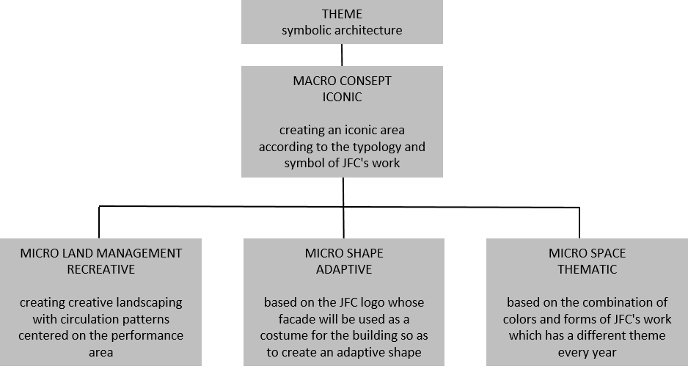Design Concept

Figure 4.0 design concept diagram
Source: Personal Documentation

The micro concept of land use in the design and planning of the Fashion Carnaval Cultural Activity Center in the City of Jember is Iconic. Because with the JFC celebration, the image of the City of Jember has become global. So the city was given the nickname as the "City of Carnaval". Then a design will be made that can reflect the symbolic City of Jember with its Carnival City, which is also identical to the form of JFC's iconic works.
The micro concept of land use in the design and planning of the Center for Fashion Carnaval Cultural Activities in the City of Jember is recreational. Based on the creativity that gave birth to the beginning of the formation of JFC. So that the land use that will be applied is a metaphor for the transformed JFC logo symbol. Then use a centralized circulation pattern. Taking the philosophy of the JFC celebration then it can raise all aspects in the City of Jember and focus on the JFC event. Starting from the cultural aspect, with the celebration of the JFC event which has become the culture of the people of the City of Jember. Then the economic aspects of the people of Jember City are increasing, as well as the tourism aspect which makes many local and foreign visitors come to Jember City to witness the JFC celebration.
Micro Concept The shape in this design is adaptive. The existing building consists of several supporting buildings, and there is a main building, the shape of the building will be made adaptive by adapting the costumes as the facade of the building.
The concept of micro space in this design is thematic. Based on the philosophy of JFC's fashion creations, which have a different theme every year, the theme is based on a blend of Indonesian culture combined with trending things.

- Design Results
Land Management

Figure 5.1 land use
Source: Personal Documentation

The concept applied in the following land plan is Recreation which has the philosophy of the JFC logo and uses a centralized circulation pattern, aiming to facilitate the circulation of visitors in their activities with the performance arena which is the center of the area.
Shape
The concept of shape design applied in this project is adaptive which means adjustment. The shape of the building adapts to the design title, namely costumes. So that the facade of the building will be made into a costume for the building. The application of the curved facade like a wing is an adoption of the symbol of the JFC logo. Which is applied as a costume/secondskin for buildings using GRC board material because it has a high degree of flexibility and is easy to apply as a secondskin façade.
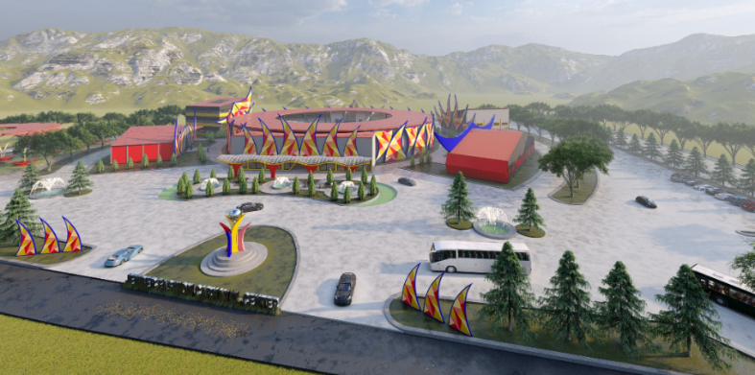

Figure 5.2 shape
Source: Personal Documentation
Room
The concept of space design applied in this project is thematic, that is, it adopts several costume themes that exist in JFC. Starting from the coloring to the arrangement of the space.

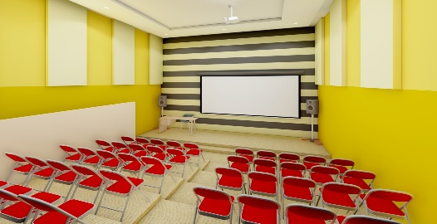
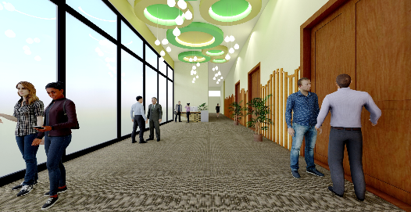

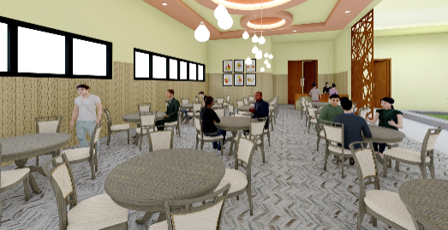
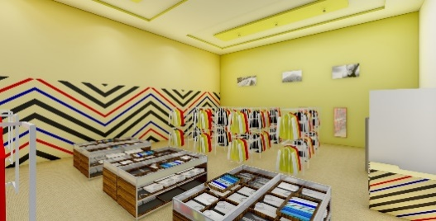
Foyer Convention Hall Training Room

Souvenir Shop Restaurant Interior
CONCLUSION
The design of the Fashion Carnaval Cultural Activity Center in the City of Jember is a forum that will be built to accommodate the JFC celebration activities which have become very global, along with a range of other activities in the City of Jember. The goal is to maintain the preservation of JFC culture and other arts activities in the City of Jember, as well as to improve the economic and tourism aspects in the City of Jember. So that this place is not only intended for JFC activities, but can also be used for other activities in the City of Jember.
So with the design of this area, it is also expected to be able to increase the awareness of the younger generation to participate in maintaining and preserving Indonesian culture, especially in the city of Jember. The city which has the nickname as the "City of Carnaval". So that the name of the city of Jember remains fragrant and continues to grow as this Carnaval City.

DAFTAR PUSTAKA
[1] D. By, “PAPUA ARTS BUILDING AS A CENTER FOR ART AND CULTURE,” p. 11.
[2] E.A. Arung and E. Poedjioetami, “BALIKPAPAN SYMBOLIC APPROACH TO THE DESIGN OF SEAFOOD TOURISM CENTER IN BALIKPAPAN,” p. 5, 2020.
[3] E. Kristiani, W. W. Widjajanti, and F. H. Hendra, “Shape ande space: Banyuwangi opera house with a coastal environmental approach,” J. Phys. conf. Ser. , vol. 1833, no. 1, p. 012021, Mar. 2021, doi: 10.1088/1742-6596/1833/1/012021.
[4] A. Tampubolon and C. Darmawan, “National Cultural Fashion in the Context of National Insight: A Case Study at the Jember Fashion Carnaval,” J. Urban Soc. Arts , vol. 3, no. 1, pp. 19–26, Apr. 2016, doi:10.24821/jousa.v3i1.1473.
[5] AFF Rizal, WW Widjajanti, and RP Salisnanda, "Application of Environmentally Friendly Architecture in the Design of an Embroidery Center in Pasuruan Regency, East Java," p. 8.
[6] W. W. Widjajanti, “EXISTENCE AND OPTIMIZATION OF GREEN OPEN SPACE FOR CITY LIFE,” p. 7..

